**Predicting Profitability**

Executive Summary  
  
The sales department has prepared a list of 17 possible products to launch, of which they will launch only 5. The objective of this report is the profitability of these products. The 5 products that have given us the most profitability in the future.

Analysis

Below we list the products from highest to lowest profitability, therefore we recommend to launch the following:

|  |  |  |  |  |
| --- | --- | --- | --- | --- |
| Ránking | Product ID | Product Type | Brand | Profitability |
| 1 | 186 | Tablet | Apple | 102.342.74 |
| 2 | 187 | Tablet | Amazon | 68.679.74 |
| 3 | 180 | Netbook | Acer | 43.898.62 |
| 4 | 199 | Game Console | Sony | 36.342.07 |
| 5 | 176 | Laptop | Razer | 21.375.25 |

Other basics by product

* Product 186. Apple Tablet: Currently we do not have a tablet of this brand, given the importance of this brand is one more foundation to have it among our products.
* Product 187. Amazon Tablet: Currently we do not have a tablet of such an economic price and a brand that is growing as much as Amazon, has the same profit margin as our Samsung tablet product number 188 and is € 300 more economical.
* Product 180. Acer Netbook: The recommendation is to enter this Netbook and remove Samsung's product number 177 since it is not working in terms of sales. This netbook is cheaper than Samsung's and also leaves us 0.8 more profit margin.
* Product 199. Game Console from Sony: The Game Console category is the second one that gives us the best profitability in Blackwells Electronic, therefore, and given the good behavior of these products in our store, we believe it is essential to include a brand that has not been included until now. We had built-in our Consoles, Sony.
* Product 176. Razer laptop: This high-performance laptop leaves us with a margin of 0.23 much higher than the others we had in mind to incorporate Stock.

Based on

Our technical analysis is based on the idea that the new products we plan to launch share attributes with those previously sold, this fact allows us to predict what the profitability of the new products will be.  
  
To choose the 5 products that will give the best performance to the company, we have also studied the behavior of the Blackwell Electronic customer in terms of the products that are best sold, adapting to the client's taste.

Conclusions

After having analyzed the 17 products, we can conclude that the 5 that we have chosen previously are those that are more profitable in the future in Blackwells Electronic, both for the technical analysis that has been made and for the behavioral study carried out .  
  
It is worth mentioning that the profitability figures are not exact but they are indicative regarding the future behavior of these new products.

**Technical Annex**

Methodology per product:

The analysis is based on the most accurate prediction of the KNN and GBT models, which are the best results and error metrics given when optimizing. The main criterion is to choose between the products that work best in both models supporting our decisions with the behavior of the Blackwells Electronic customer.

* Product 186. Apple Tablet: Using the optimized algorithms KNN and GBT, we see that the prediction is the highest and also very accurate between our algorithms (KNN: 108,093.34) and (GBT: 96.592.13). This fact tells us that our models work very similarly and predict similar, therefore seeing the good behavior we make an average of both to diversify error (KNN / GBT: 102.342.74).

Product 187. Amazon Tablet: Using the optimized algorithms KNN and GBT we see that the prediction is the second one in terms of greater value and they are also somewhat related (KNN: 76.464.20) and (GBT: 60.895.27). This fact tells us that our models work very similarly and predict similar, therefore seeing the good behavior we make an average of both to diversify error (KNN / GBT: 68,679.74).

* Product 180. Netbook from Acer: Something similar to the previous thing happens as well, we see that our results in both algorithms are very similar (KNN: 42,492.99) and (GBT: 45.304.25) and also in terms of volume it is in third place. We decided to make an average to diversify error (KNN / GBT: 43.898.62).
* Product 199. Sony Game Console: With this product still coming out in place 5 of KNN with 38,700.25 in GBT came out in sixth place with 33,983.88, we have chosen it because on the one hand, both models predict similar what we it says that we are in certain predictions and on the other hand because Game Consoles is our second best category in profitability regarding the History of Blackwells. (KNN / GBT: 36.342.07).
* Product 176. Razer Laptop: With this product we have used the same criterion, a prediction of the two models very close and precise, therefore making the average of KNN and GBT we get the next one that we categorize as our 5 best product as soon as to profitability (KNN / GBT: 21.375.25).

Metrics of the Algorithms that we choose

In our analysis we used an average between the KNN and GBT Algorithms since they are the models that better metrics have reported to us after optimizing them.

KNN

K: 2

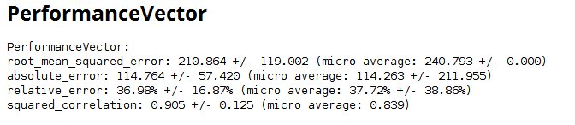

GBT

Trees: 90

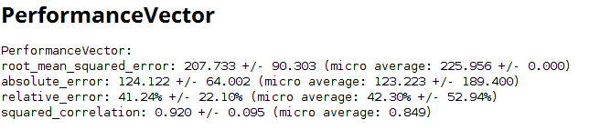

Metric of the SVM that we decided not to choose.

C: 20

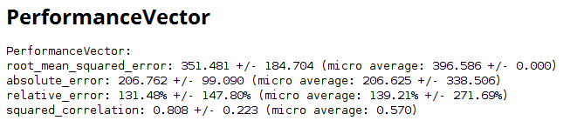

Plot of KNN

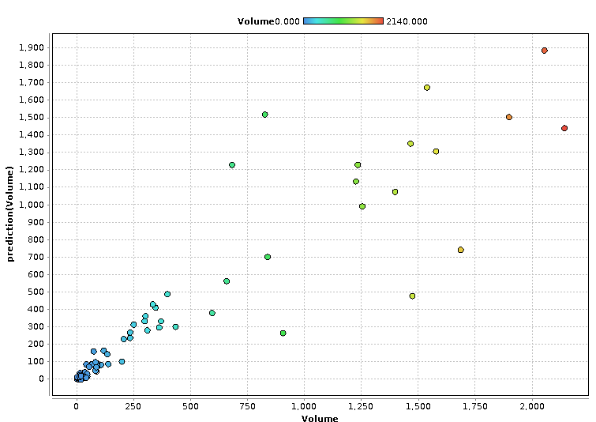

Plot of GBT

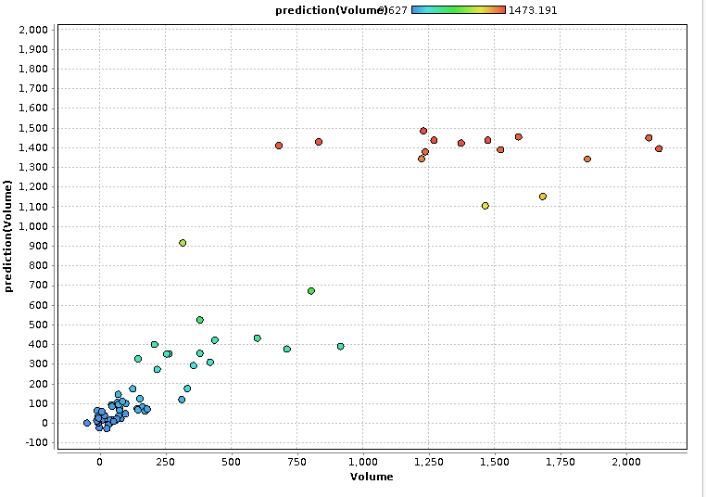

Optimization of models

For the optimization of the models we do the following:

* Removal of outlayers filtering the volume above 6,000 to not bias our model.

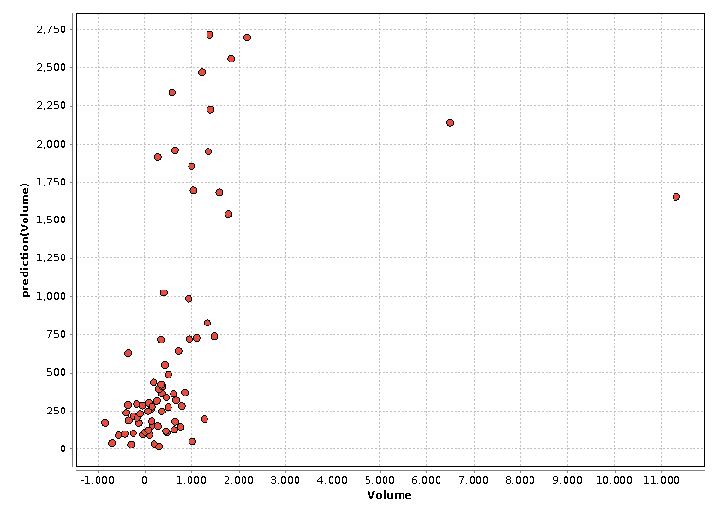

* We eliminate the attributes that have a correlation with Volume between -0.5 and + 0.5 since they do not tell us anything and we are left with the ones that are most related. In addition, we analyze the collinearity between the variables and eliminate any indication that it may exist so we will not have an overfit model. Therefore we could summarize that we chose the following:

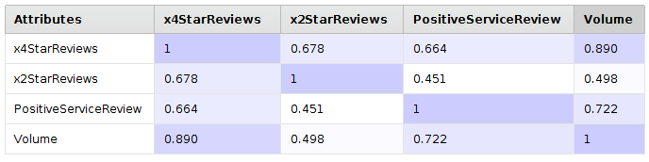

* In addition we move to optimize each Algorithm by testing with the different parameters, we choose K2 for KNN and Tree: 90 for GBT.

TOP 6 GBT

|  |  |  |  |  |
| --- | --- | --- | --- | --- |
| TOP 6 GBT | | | | |
| 1 | PC | 171 | Dell | 141.769,26€ |
| 2 | Tablet | 186 | Apple | 96.592,13€ |
| 3 | Laptop | 173 | Apple | 91.668,23€ |
| 4 | Tablet | 187 | Amazon | 60.895,27€ |
| 5 | Netbook | 180 | Acer | 45.304,25€ |
| 6 | Game Console | 199 | Sony | 33.983,88€ |

TOP 6 KNN

|  |  |  |  |  |
| --- | --- | --- | --- | --- |
| TOP 6 KNN | | | | |
| 1 | Tablet | 186 | Apple | 108.093,34€ |
| 2 | Tablet | 187 | Amazon | 76.464,20€ |
| 3 | PC | 171 | Dell | 43.571,64€ |
| 4 | Netbook | 180 | Acer | 42.492,99€ |
| 5 | Game Console | 199 | Sony | 38.700,25€ |
| 6 | Laptop | 176 | Razer | 23.910,34€ |

History of profitability by categories

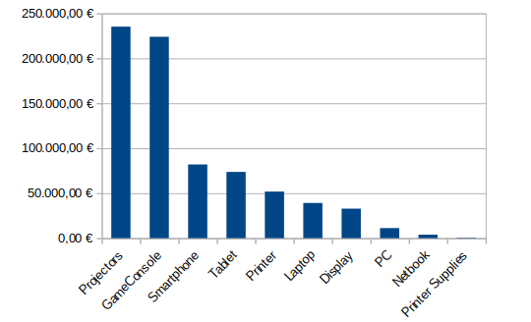

Final comment

We can see that PC 171 is part of the two models and also predicts a large amount for GBT (141.769,26) and a not-so-large amount for KNN (43,571.64). This product has not been chosen for two reasons:  
   
1- There is no relationship between the two models therefore makes the prediction less credible.  
2- The PC category is the third least profitable.

Histórico de categorías para analizar el comportamiento del cliente



|  |  |  |  |  |
| --- | --- | --- | --- | --- |
| **Ránking** | **Product ID** | **Product Type** | **Brand** | **Profitability** |
| 1 | 186 | Tablet | Apple | 102.342.74 |
| 2 | 187 | Tablet | Amazon | 68.679.74 |
| 3 | 180 | Netbook | Acer | 43.898.62 |
| 4 | 199 | Game Console | Sony | 36.342.07 |
| 5 | 176 | Laptop | Razer | 21.375.25 |